2017-03-23

First meeting of the e-procurement ontology working group

E-procurement ontology

Meeting Minutes

|  |  |  |  |
| --- | --- | --- | --- |
| First meeting of the e-procurement ontology working group | | | |
| Venue | Adobe Connect, Luxembourg city | Meeting date | 2017-03-23 |
| Author | Florian Barthélemy | Meeting time | 10:00 – 15:00 |
| Reviewed by | Makx Dekkers | Issue date | 2017-04-20 |
| Status | For review | Version | 0.06 |

# Attendees

|  |  |  |  |
| --- | --- | --- | --- |
| Name | Abbreviation | Organisation | Presence |
| Aleš Havránek | AH | Ministry of regional development Czech Republic | Luxemburg |
| Antonis Stanis | AS | Directorate of Procurement, Infrastructure & Material Management, Greece | Online |
| Athanasios Pantazis | AP | Greece | Online |
| Bertrand Cassar | BC | French Ministry of Economics and Finances in the Department of Juridical Affairs | Luxemburg |
| Claire Noël | CN | Publications Office of the EU | Luxemburg |
| Claude Schmit | CS | Publications Office of the EU | Luxemburg |
| Cyril Picard | CP | Publications Office of the EU | Luxemburg |
| Edmund Gray | EG | CENBII | Online |
| Enrico Francesconi | EF | Publications Office of the EU | Luxemburg |
| Florian Barthélemy | FB | PwC EU Services | Luxemburg |
| Galya Devedzhieva | GD | DG DIGIT e-procurement process standardisation | Luxemburg |
| Jáchym Hercher | JH | European Commission, DG GROW | Online |
| Jan Mærœ | JM | Difi, Norway | Online |
| Jennifer Moreau | JMo | OECD | Luxemburg |
| Jostein Frømyr | JF | TC 440, Edisys Consulting | Online |
| Juan Pane | JP | National Procurement Agency for the Government of Paraguay | Online |
| Loukia Demiri | LD | Directorate of Procurement, Infrastructure & Material Management, Greece | Online |
| Makx Dekkers | MD | AMI Consult | Luxemburg |
| Margareta Molnar | MM | Hungarian Prime Minister’s Office | Luxemburg |
| Maria Manuela Cruz | MMC | Publications Office of the EU | Luxemburg |
| Natalie Muric | NM | Publications Office of the EU | Luxemburg |
| Oļegs Fiļipovičs | OF | Republic of Latvia | Luxemburg |
| Oscar Corcho | OC | Universidad Politécnica de Madrid | Online |
| Patrizia Cannuli | PC | Italy Concip | Luxemburg |
| Paul Kollias | PK | Greeks Ministry of Economy & Development -Public Contracts & Procurement | Online |
| Polyxeni Mylona | PM | Publications Office of the EU | Luxemburg |
| Vassilios Peristeras | VP | International Hellenic University | Online |

# Agenda

|  |  |
| --- | --- |
| ID | Description |
|  | Round table |
|  | Introduction to the project |
|  | Draft Project charter and time plan |
|  | Working environment |
|  | Methodology |
|  | Initial results – conceptual model based on three use cases |
|  | Additional use cases for consideration |
|  | Next steps, planning work until June 2017 |

# Round table

MMC introduced the project and stressed the need for collaboration in the process of developing an ontology for the e-procurement area.

MD presented the agenda for the meeting, and invited all the participants to present themselves.

Each participant introduced him/herself.

OF said he was interested in the new ideas that could be opened during this project.

JF mentioned that he hopes TC 440 could participate in the development of this ontology together with this working group in order to achieve a consistent standard vocabulary for the e-procurement area.

# Introduction to the project

MD mentioned that he would like to introduce the project and what the Publications Office and PwC have done so far. The respective introduction slides are in Annex I - Introduction slides.

He described the Landscaping report written in 2016 as the basis for the current project and the background to the project.

MD explained the schema on slide number 10: We come from a closed world where each e-procurement initiative defines and exploits its own information for the integration of applications. We need through this project to convert those silos into one linked data ontology which would enable initiatives using it to be independent from applications in an open world (TO BE situation). Some initiatives are already active in this conversion.

## Questions

JF said that linked open data requires unique ID and asked if it is also the case for the values of the data?

MD answered that the literals need to have URIs.

There are two type of things: resources and literals, in the example on slide 13, resources are represented by the green ellipsis.

JF pointed out a typo on slide 14.

For JF, common semantic definition for business transactions have been defined.

And there exists a core set of entities which are definitely not part of the closed world.

MD said that different purposes are in place, this working group will integrate the semantic definitions developed by TC440 and other initiatives. This working group will try as much as possible to reuse existing concepts and definitions.

VP mentioned that the relationship and alignment between TC440 model and the e-procurement ontology is very important and should be achieved with the work of the work here.

PC asked if there is any connection between this project and the ontologies existing at the European level (e.g. Good relations).

MD answered: the working group with the support of the Publications Office and the subcontractors are going to build on what is existing (e.g. PPROC) in the XML world and the OWL world. The objective is not to reinvent the wheel.

# Draft Project Charter and time plan

The different slides relative to the Project Charter and the time plan are documented in Annex II – Draft project charter and time plan slides.

NM said that, as part of the first phase, three use cases have been started, the members of the working group were asked to contribute as well to improve those three use cases.

As from the next phase (development), the working group will take the lead. The process has been defined as part of the first phase.

MD mentioned that this work will be collaborative in each of the methodological steps. There are two documents providing guidelines, one describing the conceptual model itself (technical part), and one describing the dynamics of the working group for this project (project charter).

By the end of this first phase (June), MD and NM said that they would like to have a collaboratively defined set of use cases. To provide the initial input for the second phase along with the conceptual model and workings produced from the initial three use cases.

MD said that after every meeting in the second phase, the editor and the support team will make sure that the outputs from the last meeting are implemented to allow new contributions during the next meeting.

## Questions

JF asked when there will be a decision concerning the definition of the maintenance process.

NM said that this is not part of this inception phase but it should definitely be part of the next phase.

JF agreed with the approach.

MD asked the audience if the content of the presentation was clear so far. He mentioned that the investment per member was up to each member but to ensure maximum benefit a period between 0.5 to 3 days per month would be optimal to enable the working group to go further with the development.

# Working environment

|  |  |
| --- | --- |
| Resource | Product/tool |
| Ontology development tool | Protégé, <http://protege.stanford.edu/> |
| Model visualisation tool | TBD |
| Conference call facility | Adobe Connect, <https://ec-wacs.adobeconnect.com/> |
| Mailing list | Joinup, [eprocurementontology@joinup.ec.europa.eu](mailto:eprocurementontology@joinup.ec.europa.eu) |
| Issue tracker | GitHub, [https://GitHub.com/eprocurementontology/eprocurementontology](https://github.com/eprocurementontology/eprocurementontology) |
| Publication channel | Joinup, <https://joinup.ec.europa.eu/asset/eprocurementontology/description> |

MD explained the mailing list allows everybody involved to see the messages and it is publicly archived which enhances the transparency. It should be used to share inputs of general interest for the working group members.

MD described the GitHub repository for this project. GitHub should be used to describe any issue/solution/comment concerning documents uploaded on the publication channel (Joinup). The editor and chair will assure the periodicity of the maintenance (e.g. issues linked to documentation, issues and solutions categorised).

To use GitHub the working group members need to:

* + Create an individual account (on top of the home page)

It would help to:

* + Read the README document on the home page of the repository ([see link above](https://github.com/eprocurementontology/eprocurementontology)). It contains different important information about the functions of this repository such as the licence statement, the wiki, and the Joinup project.
  + Start analysing the content of the project on the wiki. It includes the necessary information from the D02.01 Specification document on Joinup.
  + Create an issue by following the templates and methodologies described in the wiki anytime it is required:

<https://github.com/eprocurementontology/eprocurementontology/wiki>

The editor will take care of the suggestions and issues every couple of weeks and if needed will organise discussions about certain points.

NM highlighted that if members have problems using this repository or to create issues, they should feel free to contact Florian (Barthelemy.florian@be.pwc.com) or herself.

MD said that the visualisation tool will be defined.

He also pointed out that the conference call is Adobe Connect but it might change in the future. In any case, a link will be provided to allow virtual meetings.

OC supported positively the initiative to use GitHub as issue tracker.

# Methodology

## Overview of methodology

MD: Based on the documents listed in Annex III – Methodology, the different steps of the process to create a final ontology were defined. This methodology is being tested and refined based on application to the three use cases within this working group.

## Five main steps

MD mentioned that, as just described, the first draft of the ontology was developed at the same time as the methodology so as to test it and adapt it if needed.

MD went through the different steps:

* + Step 1: describe a use case – a use case helps identifying a particular situation in which the main information are contained. The use case is specific, which is why a generalisation will be needed in step 2.
  + Step 2: the entities should be generalised from literals to concepts. In this step, the working group members should use the wiki on GitHub to propose new requirements in the right template.
  + Step 3: start the conceptual model - similar concepts, or concepts alone in the scheme will be identified at this stage. The relationships and information contained by each concept will be developed there. The objective is to apply this step for all use cases at the same time. It will allow the combination of the the different entities from the use cases and will help to identify which ones are required or not.
  + Step 4: consider reusing ontologies - look at existing ontologies and identify what should be reused. For this step, clear definitions of each concept of the conceptual data model should have been agreed on.
  + Step 5: not difficult for an ontology expert.

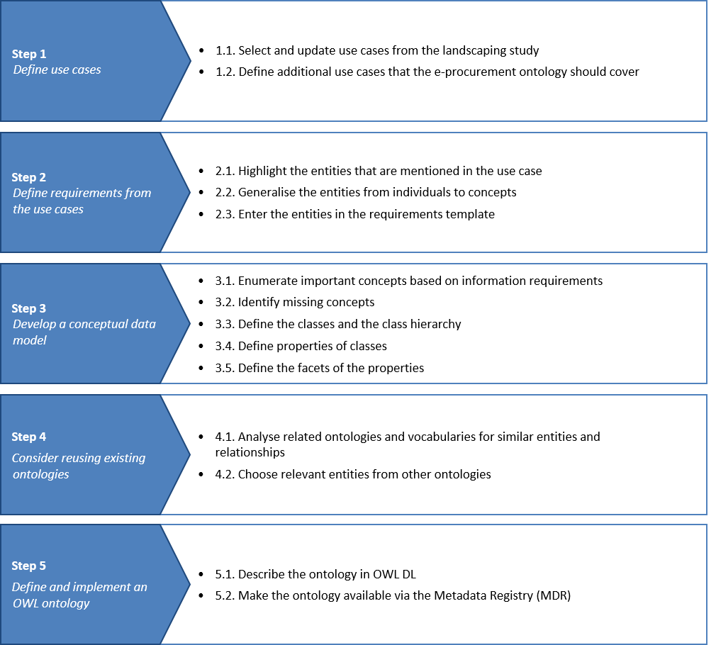

## Questions

OF asked, concerning the methodology, if some investigations had already been conducted to identify existing works. For example, the work done by Latvia on a centralised repository for identifying all businesses or another work concerning the interconnection between two repositories (the ESPD provides evidence for instance for the exclusion criteria). The ESPD project is described in the [Landscaping report](https://joinup.ec.europa.eu/asset/eprocurementontology/document/report-policy-support-e-procurement).

MD answered that part of the previous work (landscaping report) identified relevant initiatives, but it is not an exhaustive list and it was developed last year. He invited the working group members to share the different initiatives they know to allow the whole group to decide whether it is relevant or not and to come up with a list of relevant initiatives. For example concerning the second example, if a member thinks it is relevant to have one use case about it, a new use case should be submitted on GitHub and the working group will decide whether to include it or not. This work will also help to cross-fertilise other initiatives such as the ESPD.

MD highlighted the importance of submitting issues because that is how the working group will enrich this project. The imagination of the working group members is the current limit. Later on (second meeting of the working group) we will scope appropriately while taking into account the resources available and the timeframe.

BC asked about the difference between the e-procurement ontology and e-Certis.

NM answered that this ontology will be able to connect databases and repositories cross-countries. The main difference with e-Certis is that with this ontology a user can extract the one relevant piece of data he/she requires, from a larger source without needing to extract the source.

PC mentioned that Italy is very interested in the first use case because it is exactly what they are doing. There might be a problems with the level of details for the classification of goods and services. They will analyse it and raise an issue on GitHub if needed.

NM highlighted that the ontology project is funded by ISA² and part of the ISA² action: European Public Procurement Interoperability initiative. Another part of this action is led by DG GROW and deals with updating CPVs. She highlighted the fact that the results of this work will be open and freely reusable.

She pointed out that the wiki on GitHub is there as support for the members and that members should not hesitate to create issues on material that interested them. In the Italian case, she asked PC not to hesitate to raise an issue about the use case 1.

JP wrote in the chat that one very important source of information they used in Paraguay for the procurement process was the National Budget (to know where the money to pay the contracts comes from). He asked if anyone had a reference ontology for that, or if this was included in the scope of this work.

OC provided a link that might be in line with what JP was asking for. He wrote that the link concerns a project which had been done in Spain from a local government perspective: <http://vocab.linkeddata.es/datosabiertos/def/hacienda/presupuesto> (in Spanish only). He also explained that, in the current open data which had been published, contracts and budget are not connected.

JP added that the same approach was used initially in Paraguay but there is a lot of value of linking the invoices with the budget used for paying those. He wrote that it is not required to include this as part of the work done in this project but it is a very important part of the information for the procurement implementation. At the moment, Paraguay is active on this connection.

FB wrote to JP that the Paraguayan case could be a potential new use case to be proposed on the GitHub issue tracker.

# Initial results

The initial results for the three use cases are described for each step of the methodology in the slides in Annex IV – Initial results.

MD described the three different use cases and said that if there is any comment, issue or suggestion about a use case, it should be shared with everybody on GitHub.

As part of the first step (defined use cases), the working group are requested to review the use cases proposed in the landscaping report and select the ones that should be in scope, proposing updates to the use cases as necessary.

The working group members should propose and agree on new use cases where they feel a need is not covered by the selected use cases or from the sum of more than one use case.

When creating a flow for a use case ([see example for use case 1 on data journalism](https://github.com/eprocurementontology/eprocurementontology/wiki/Use-case-1:-Data-journalism)) working group members should be as precise as possible, it is important to note that the use case description and/or the flow do not need to be perfect from the first try. Technical profiles and procurement experts will enrich the propositions from each other.

In step 2, MD pointed out that the entities underlined are not all important but the important ones are listed as information requirements. He invited the working group to look at the existing list of information requirements created and to add one if it is relevant. The template for the information requirements is available in the [wiki on GitHub](https://github.com/eprocurementontology/eprocurementontology/wiki/Information-Requirements).

MD showed an example for step 3 and explained that the development of the conceptual model is subject to discussion within the working group.

Concerning the relationships, the labels are subject to discussion as well as the relationships: the working group needs to decide if some should be double (two directions relationship) or if a one way relationship is making more sense.

MD said for step 4 that the term “considering for reuse” was used in the document because it should be subject to discussion with the working group (e.g. are the definitions from other ontologies to be reused exactly as they are or not: for instance in the case of tender and call for tender).

MD said that the full list of ontologies and vocabularies identified until now is available in the Landscaping report. Members of the working group are free to propose any other source.

MD also said that for each concept coming from other ontologies, a reusability level should be fixed. It is based on this level that the working group will decide whether to reuse the concept or not and what to reuse (the definition, the label etc.)

NM: Suggested a list of these sources should be put on the wiki so that people can add to it

An automated tool could help selecting concepts from existing ontologies but it should be part of the responsibilities of the working group to see whether to use some automated tool or not.

JP commented that such a tool would be useful to consider the reuse of already existing definitions because at the moment the process is manual and depends on each person's knowledge of the existence of other ontologies/vocabularies.

JP asked through the chat which phases of the procurement process were going to be included in the ontology modelling.

FB answered that the scope of the ontology should be from e-Notification to e-Invoicing (as mentioned in the Project Charter).

Florian Barthélemy (PwC): @Juan: we will put your question on our list, there are several things mentioned in the third reference for methodologies (author Elena Paslaru).

MD rephrased: this step consists of converting all the boxes and relationships from the conceptual model and the tables into one OWL ontology as shown in the example.

## Questions

JF asked if synonyms will be identified as existing concepts to be reused or not.

MD answered that finding synonyms is a necessary step. The mapping in the step after will decide if the definition of the concept is broader or. As a consequence, a super or sub-class could be created if the working group decides so.

JF asked if there was a methodology to translate OWL to skos.

MD was not sure if there exists an exact translating tool.

JF proposed to use UML diagram instead of concept diagram.

MD said that concept diagram was used but UML diagram could be used in later stages if the working group decides so.

For JF, the main disadvantage of a concept diagram compared to a UML diagram is that it has no exact definition. So you always end up in defining exactly what you mean with the different elements of your diagram and in justifying the structure of your diagram. While a UML diagram is already defined and recognised by the community.

OF would like to use the concept diagram at the moment because it is sufficient for the current stage. But he agreed that a more formal way could be used later on (e.g. UML diagram).

# Additional use cases

MD briefly described the list of use cases defined in the previous report. The list is available in Annex V – Additional use cases and each use case is described in the Landscaping report. He said that they were divided in three categories:

* + Transparency and monitoring
  + Innovation and value added services
  + Interconnection of public procurement systems

MD pointed out that the working group should say if they think they need some of the use cases above or not. If, from their experience and background, the working group members think that important use cases are not represented here, they should provide a new use case through GitHub or the mailing list.

MD said that the mailing list is also useful if you encounter a problem or any difficulty because some other members could have the same problem.

# Next steps

## Tasks for the working group:

**April—June 2017**

* + Before Easter- Contribute , propose & review of methodology, charter and initial ontology on GitHub
  + Before Easter- Refinement of additional use cases:
    - Propose changes in existing use cases from the landscaping report;
    - Propose new use cases by filling the template provided in the specification.

NM said that comments should be given before the end of Easter to have the time to process the different inputs before the next meeting.

**26 April 2017** – 2nd Meeting with Working Group – Agreement on use cases:

* + Read the proposed changes in the documents before the meeting.
  + It will be a virtual meeting
  + We will have worked on the different issues and comments raised before Easter

**8 May 2017** – Refinement of methodology, charter and initial ontology on GitHub

**TDB: 23 May 2017** – 3rd Meeting with Working Group:

* + Read the final propositions for acceptance for this first phase.

## Questions:

JF asked if a membership was required on Joinup.

MD answered yes if someone wants to receive notifications each time a new documents/event is published.

He also said that a user account on GitHub should be created and that, in order to be part of the mailing list, members should explicitly mention it to Natalie and Florian.

NM asked the audience if they prefer to divide the work during this first meeting or in later stages.

For OF the work should be individual until the next meeting. The audience agreed.

NM highlighted that the next meeting will be the 26th of April in the afternoon (13:00 to 16:00). The participants agreed with the date.

PwC will put links from GitHub to allow direct downloads of the documents on Joinup.

PwC will also put the link of GitHub on Joinup and mention it clearly.

# Conclusion

MMC thanked everyone, she highlighted the importance of developing something really useful and the need to collect the inputs of everyone to achieve this. For example, some new use cases could improve this ontology to help future users of the ontology without any knowledge of data to access important information.

# Annex I - Introduction slides

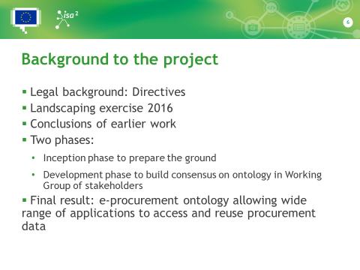

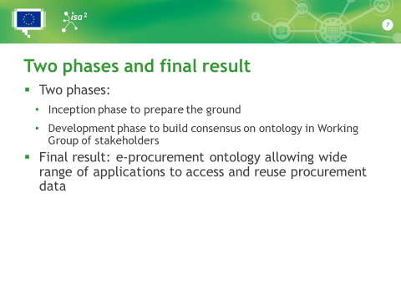

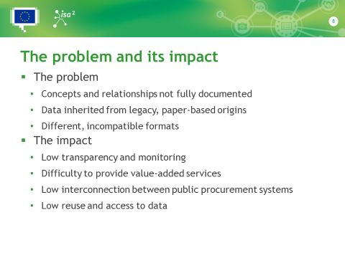

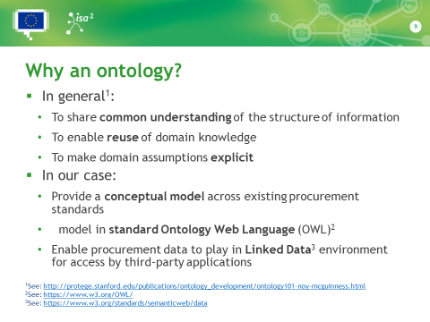

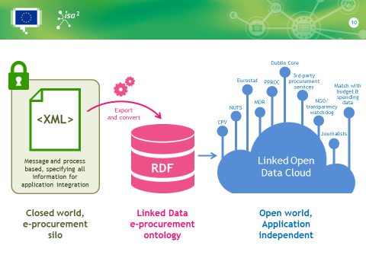

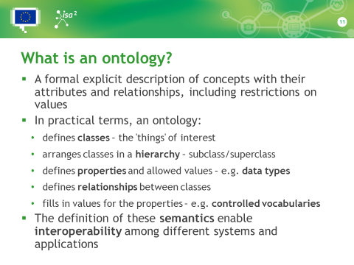

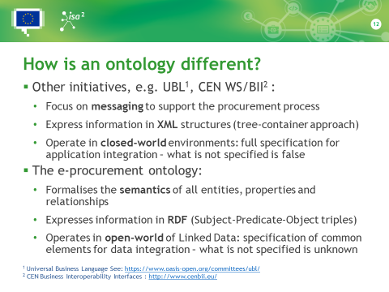

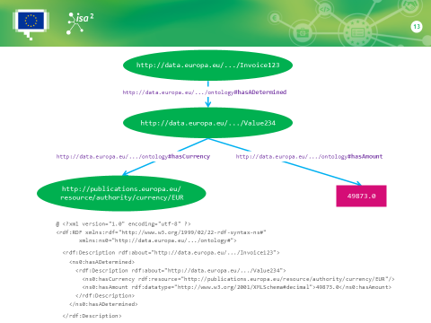

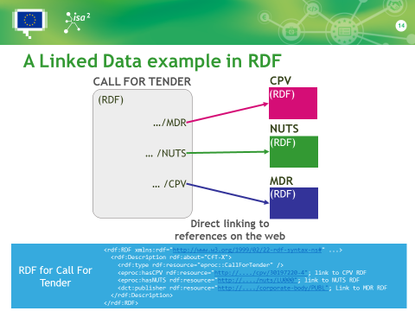

# Annex II – Draft project charter and time plan slides

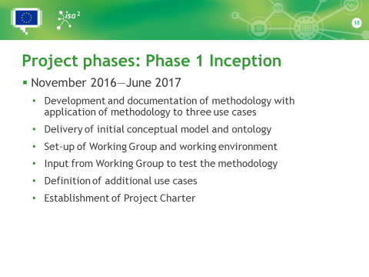

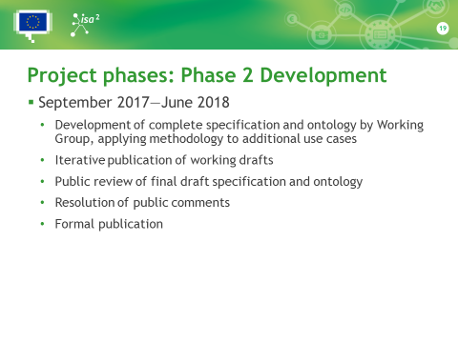

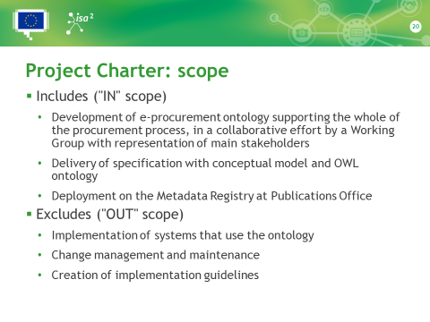

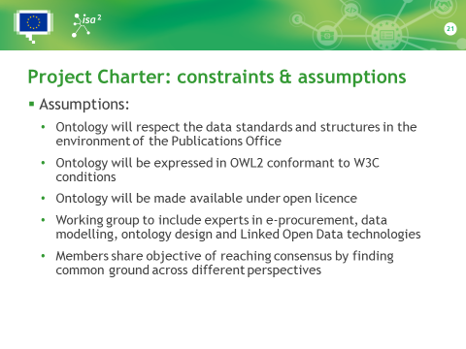

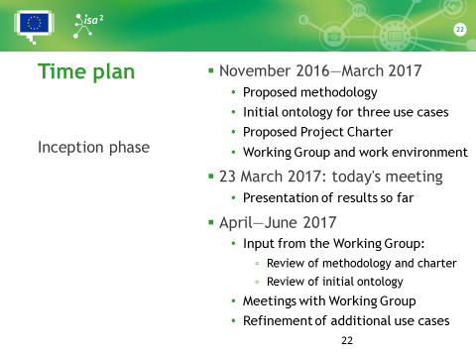

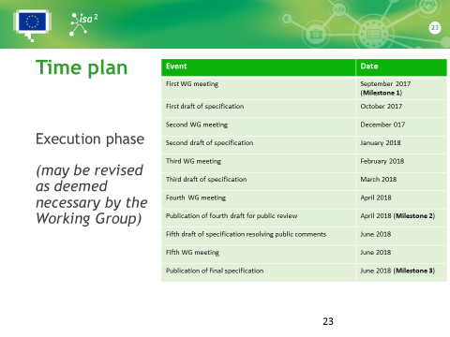

# Annex III – Methodology

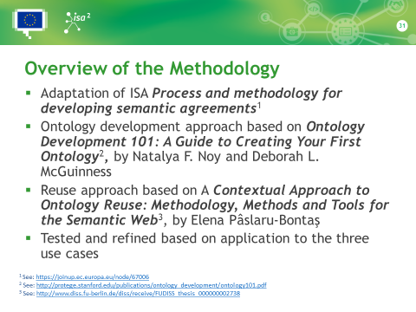

# Annex IV – Initial results

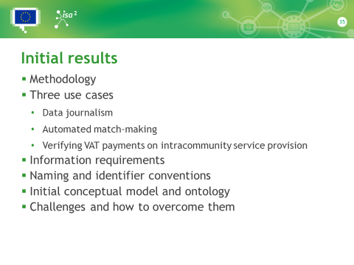

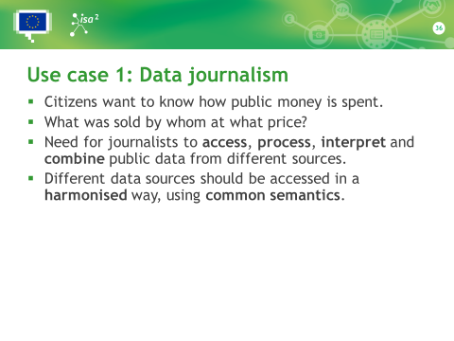

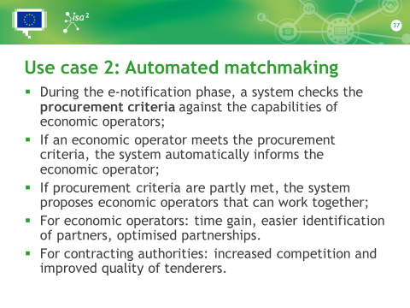

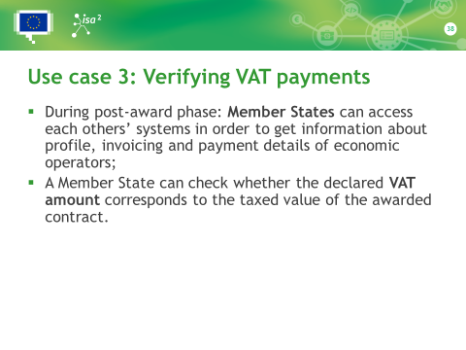

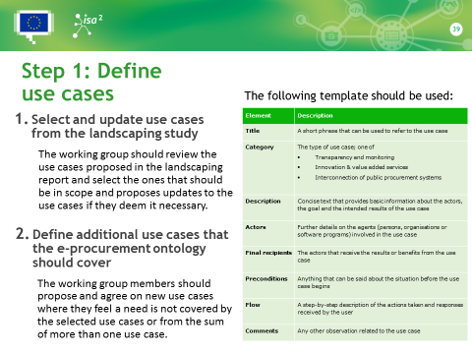

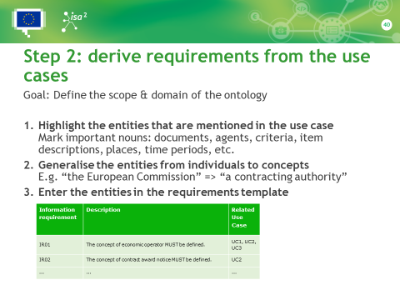

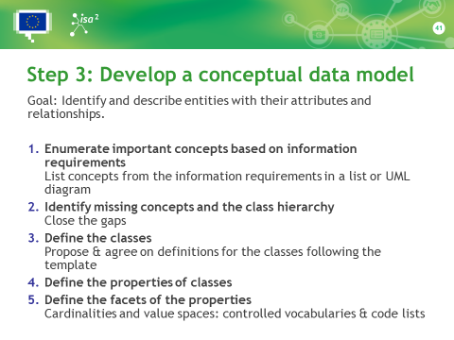

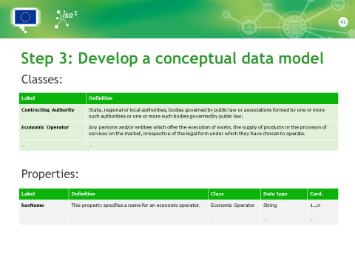

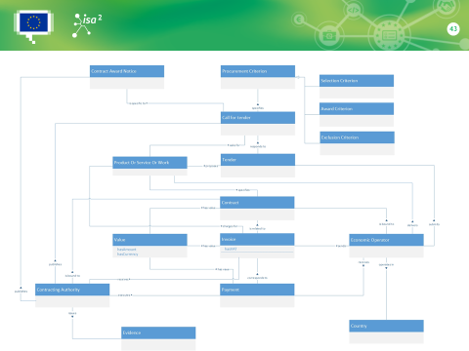

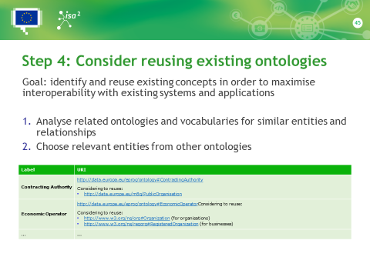

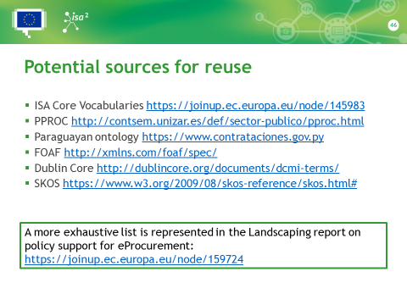

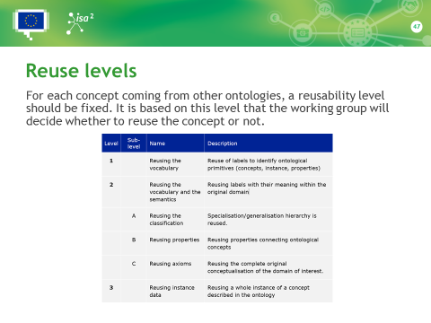

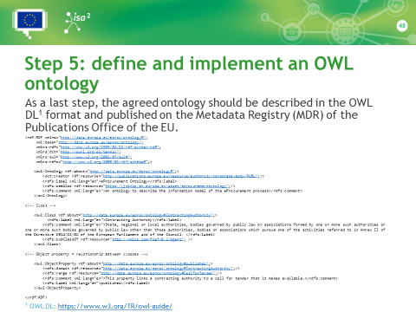

# Annex V – Additional use cases

